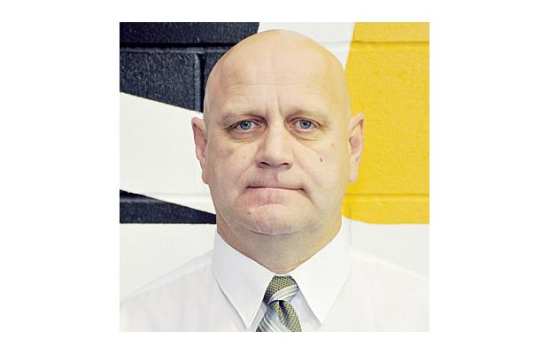 Harvey Smyl

On-Ice Instructor:
Harvey started his professional career as a hockey player with the St. Albert Saints team in 1980 and went on to play at Michigan State University NCAA hockey.
Coach Smyl started his coaching career with the Chilliwack Chiefs in 1993 and, after 5 years in Langley, is returning as bench boss for the Chiefs.
As Head Coach & General Manager, 2011 is Harvey’s 19th season at the helm of the Chiefs organization. Harvey's Chiefs have always advanced to the play offs including three BCHL Championship teams, 1994-95, 1999-00, and 2001-02. Twice those teams advanced to the Royal Bank Cup, which included a Bronze Medal in 2000. He has been BCHL Coach of the Year four times. In his spare time Harvey enjoys spending time with his wife and his children.

Neil Murphy
On-Ice Instructor: Neil played Junior A hockey with the Vancouver Centennials in the BCJHL, was drafted by NHL's Boston Bruins and played 3 years for the Boston Braves (the Boston Bruins farm team) in the AHL. Coach Neil has successfully coached minor hockey at various levels in the Chilliwack area for almost 30 years. As head coach for CMHA Midget AAA (1993-1994), his team won the Provincial Championships, and placed 3rd in the Province the following year. More recently, his CMHA PeeWee AAA Bruins (2009-2010) team won their Divisional Banner. Neil has also worked as an on-ice instructor and developed several Hockey and Skating Programs with CanLan Sports at Prospera Centre. Neil is currently an Assistant coach with CMHA Bantam AAA Bruins, a head coach for the '97 Prospects (out of Abbotsford), an Instructor with the Chilliwack Middle School Hockey Academy as well an Instructor with the new Sardis Bruins Academy.

Doug Ast
On-Ice instructor: Doug finished a three year stint as a player with the Chiefs in 1994 before embarking on a 13 year playing career. Doug is the only player to Captain the Chiefs for two seasons and is the Chiefs all-time leading scorer with 242 points. The 2011-12 season is Doug's first behind the Chiefs bench.

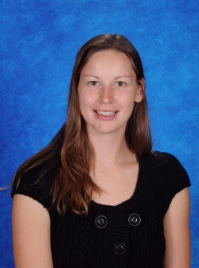

Julie Elliott
BHk, Bed, CSEP, CSCS

Off-Ice Instructor: Julie is a Physical Education and English teacher at SSS, and Athletic Director for school sports. She is a certified exercise physiologist, certified strength and conditioning specialist, and a certified Level 1 facial stretch therapist. During Julie’s studies at Vancouver Island College and UBC, she was a student athlete and doubled as an athletic trainer for varsity sports teams. As an athlete, Julie played: Varsity volleyball (at national level); semi-professional Women’s Basketball in Norway; and Pair and Eight Rowing (at national level). After retiring as an athlete, Julie returned to post-secondary life, attending UFV to complete her certification as a Kinesiologist. Since then, Julie has worked with athletes, seniors, injured individuals, and the general population, using exercise as a form of therapy and developing customized strength training programs.

Maryanne Mussell
BPE, M.Ed, CCC

Program Director: Maryanne is a vice-principal at Sardis Secondary School. She has been the Education Advisor for the Chilliwack Bruins WHL, the Education Leader for the WHL BC Division, and has returned to work with the BCHL Chilliwack Chiefs.
Her post-secondary education includes a Bachelor's degree in Physical Education and Master’s Degree in Counseling Psychology from UBC and Graduate work in School Administration from SFU.
Maryanne has a history of playing, coaching and organizational involvement with sports including: playing UBC Varsity basketball; playing Senior A Fast-pitch with Softball Canada; past President of the Surrey Secondary School Athletic Association; and executive positions with both BC School Sports and the Fraser Valley Athletic Association.
Maryanne arranged for Sardis Secondary to be a test administration site for the College-board SAT and SAT II tests, and is very familiar with the eligibility requirements for NCAA Clearing-house. Maryanne has had over 30 years of experience working with student-athletes, helping them to pursue their sport in CIS, BCHL, ACAC, and NCAA post secondary institutions.

